# TEST SCRIPT 4

**Test7：Add class(teacher)**

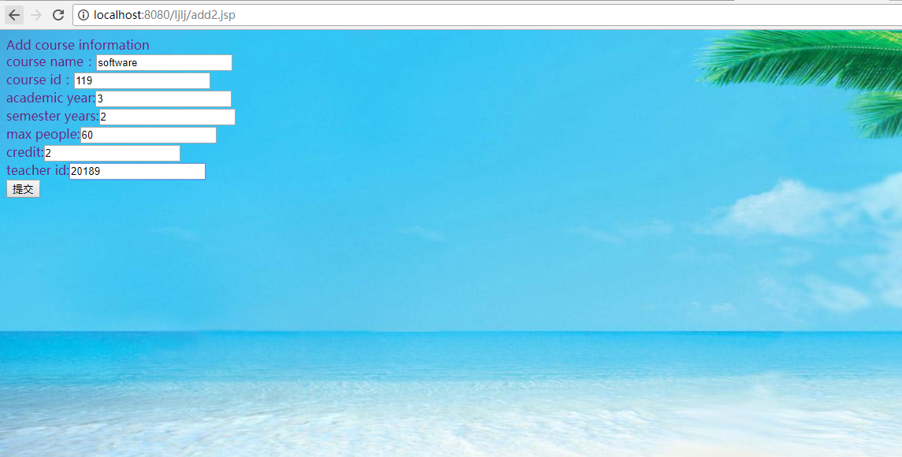

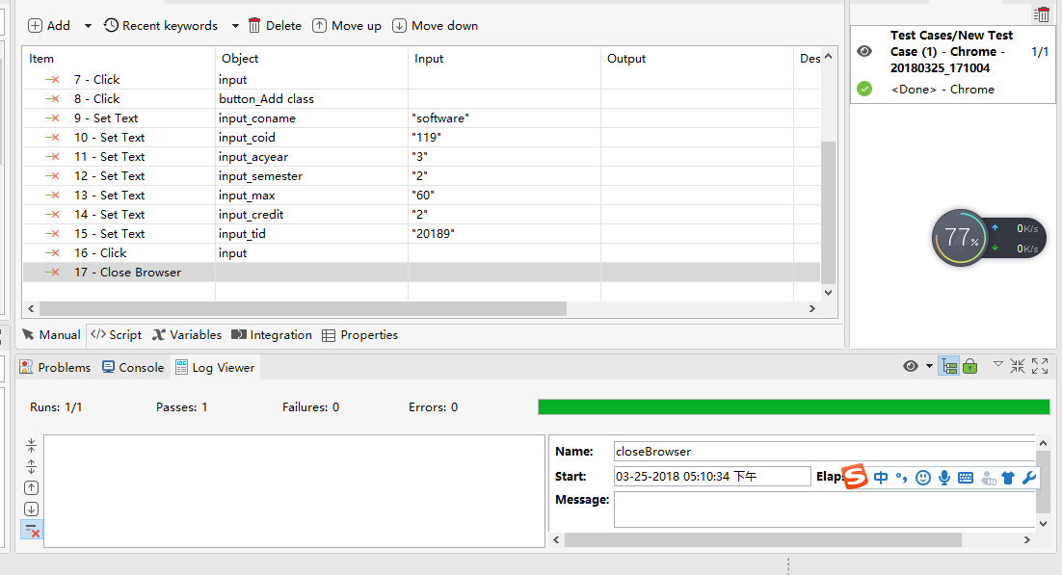

**import** **static** com.kms.katalon.core.checkpoint.CheckpointFactory.*findCheckpoint*

**import** **static** com.kms.katalon.core.testcase.TestCaseFactory.*findTestCase*

**import** **static** com.kms.katalon.core.testdata.TestDataFactory.*findTestData*

**import** **static** com.kms.katalon.core.testobject.ObjectRepository.*findTestObject*

**import** com.kms.katalon.core.checkpoint.Checkpoint **as** Checkpoint

**import** com.kms.katalon.core.checkpoint.CheckpointFactory **as** CheckpointFactory

**import** com.kms.katalon.core.mobile.keyword.MobileBuiltInKeywords **as** MobileBuiltInKeywords

**import** com.kms.katalon.core.mobile.keyword.MobileBuiltInKeywords **as** Mobile

**import** com.kms.katalon.core.model.FailureHandling **as** FailureHandling

**import** com.kms.katalon.core.testcase.TestCase **as** TestCase

**import** com.kms.katalon.core.testcase.TestCaseFactory **as** TestCaseFactory

**import** com.kms.katalon.core.testdata.TestData **as** TestData

**import** com.kms.katalon.core.testdata.TestDataFactory **as** TestDataFactory

**import** com.kms.katalon.core.testobject.ObjectRepository **as** ObjectRepository

**import** com.kms.katalon.core.testobject.TestObject **as** TestObject

**import** com.kms.katalon.core.webservice.keyword.WSBuiltInKeywords **as** WSBuiltInKeywords

**import** com.kms.katalon.core.webservice.keyword.WSBuiltInKeywords **as** WS

**import** com.kms.katalon.core.webui.keyword.WebUiBuiltInKeywords **as** WebUiBuiltInKeywords

**import** com.kms.katalon.core.webui.keyword.WebUiBuiltInKeywords **as** WebUI

**import** internal.GlobalVariable **as** GlobalVariable

**import** org.openqa.selenium.Keys **as** Keys

WebUI.*openBrowser*('')

WebUI.*navigateToUrl*('http://localhost:8080/ljlj/panduan.jsp')

WebUI.*setText*(*findTestObject*('Page_Insert title here (8)/input_juese'), 'teacher')

WebUI.*sendKeys*(*findTestObject*('Page_Insert title here (8)/input_juese'), Keys.*chord*(Keys.***ENTER***))

WebUI.*setText*(*findTestObject*('Page_ (7)/input_user2id'), '666')

WebUI.*setText*(*findTestObject*('Page_ (7)/input_user2pass'), '666')

WebUI.*click*(*findTestObject*('Page_ (7)/input'))

WebUI.*click*(*findTestObject*('Page_Insert title here (8)/button_Add class'))

WebUI.*setText*(*findTestObject*('Page_Insert title here (8)/input_coname'), 'software')

WebUI.*setText*(*findTestObject*('Page_Insert title here (8)/input_coid'), '119')

WebUI.*setText*(*findTestObject*('Page_Insert title here (8)/input_acyear'), '3')

WebUI.*setText*(*findTestObject*('Page_Insert title here (8)/input_semester'), '2')

WebUI.*setText*(*findTestObject*('Page_Insert title here (8)/input_max'), '60')

WebUI.*setText*(*findTestObject*('Page_Insert title here (8)/input_credit'), '2')

WebUI.*setText*(*findTestObject*('Page_Insert title here (8)/input_tid'), '20189')

WebUI.*click*(*findTestObject*('Page_Insert title here (8)/input'))

WebUI.*closeBrowser*()

**Test8：delete course(teacher)**

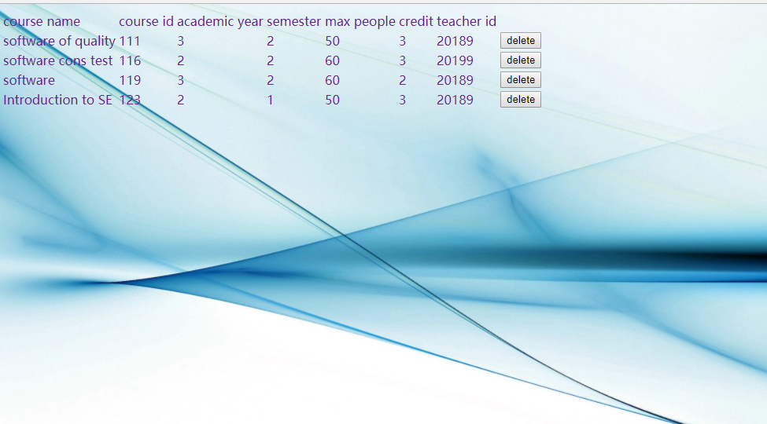

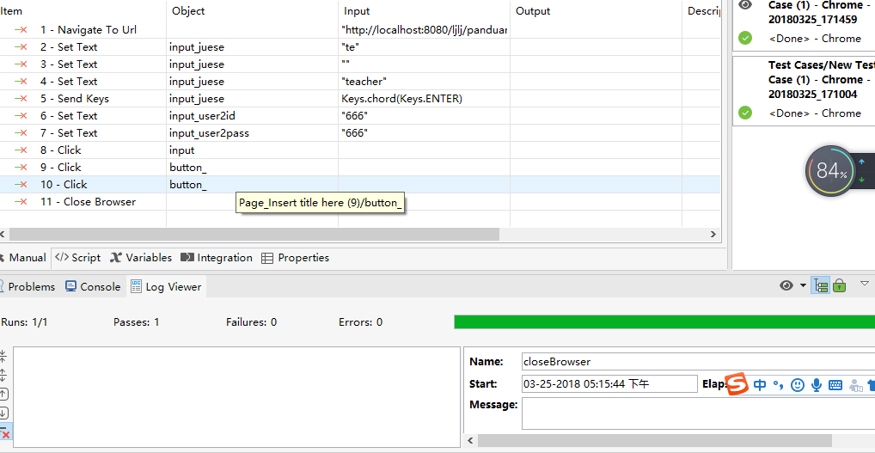

**import** **static** com.kms.katalon.core.checkpoint.CheckpointFactory.*findCheckpoint*

**import** **static** com.kms.katalon.core.testcase.TestCaseFactory.*findTestCase*

**import** **static** com.kms.katalon.core.testdata.TestDataFactory.*findTestData*

**import** **static** com.kms.katalon.core.testobject.ObjectRepository.*findTestObject*

**import** com.kms.katalon.core.checkpoint.Checkpoint **as** Checkpoint

**import** com.kms.katalon.core.checkpoint.CheckpointFactory **as** CheckpointFactory

**import** com.kms.katalon.core.mobile.keyword.MobileBuiltInKeywords **as** MobileBuiltInKeywords

**import** com.kms.katalon.core.mobile.keyword.MobileBuiltInKeywords **as** Mobile

**import** com.kms.katalon.core.model.FailureHandling **as** FailureHandling

**import** com.kms.katalon.core.testcase.TestCase **as** TestCase

**import** com.kms.katalon.core.testcase.TestCaseFactory **as** TestCaseFactory

**import** com.kms.katalon.core.testdata.TestData **as** TestData

**import** com.kms.katalon.core.testdata.TestDataFactory **as** TestDataFactory

**import** com.kms.katalon.core.testobject.ObjectRepository **as** ObjectRepository

**import** com.kms.katalon.core.testobject.TestObject **as** TestObject

**import** com.kms.katalon.core.webservice.keyword.WSBuiltInKeywords **as** WSBuiltInKeywords

**import** com.kms.katalon.core.webservice.keyword.WSBuiltInKeywords **as** WS

**import** com.kms.katalon.core.webui.keyword.WebUiBuiltInKeywords **as** WebUiBuiltInKeywords

**import** com.kms.katalon.core.webui.keyword.WebUiBuiltInKeywords **as** WebUI

**import** internal.GlobalVariable **as** GlobalVariable

**import** org.openqa.selenium.Keys **as** Keys

WebUI.*navigateToUrl*('http://localhost:8080/ljlj/panduan.jsp')

WebUI.*setText*(*findTestObject*('Page_Insert title here (9)/input_juese'), 'te')

WebUI.*setText*(*findTestObject*('Page_Insert title here (9)/input_juese'), '')

WebUI.*setText*(*findTestObject*('Page_Insert title here (9)/input_juese'), 'teacher')

WebUI.*sendKeys*(*findTestObject*('Page_Insert title here (9)/input_juese'), Keys.*chord*(Keys.***ENTER***))

WebUI.*setText*(*findTestObject*('Page_ (8)/input_user2id'), '666')

WebUI.*setText*(*findTestObject*('Page_ (8)/input_user2pass'), '666')

WebUI.*click*(*findTestObject*('Page_ (8)/input'))

WebUI.*click*(*findTestObject*('Page_Insert title here (9)/button_'))

WebUI.*click*(*findTestObject*('Page_Insert title here (9)/button_'))

WebUI.*closeBrowser*()